**Project: Housing Management System for AIUBians**

**Group Members:**

**1.Mahfuza Sharmili Jui (19-39398-1)**

**2.Nahian Sajjad (19-41154-2)**

**3.Sreejan Roy (19-39737-1)**

**Entity:**  
 **1. Student**  
S_id, S_name, S_email, S_phone, Aiub_ID  
  
**2. Flat Owner**  
F_id, F_name, F_email, F_phone, F_NID

**3. Admin**  
  
A_id, A_name, A_email   
  
**4. Flat**  
  
H_id, H_address, H_price, H_status, H_APT number  
  
**Final Table:  
Admin:** A_id, A_name, A_email  
  
**Flat Owner:** F_id, F_name, F_email, F_phone, F_NID  
  
**Student:** S_id, S_name, S_email, S_phone, Aiub_ID  
 H_ID  
  
**Flat:** H_id, H_name, H_address, H_price, H_status, H_APT number  
 F_ID  
  
 **Flat owner_Admin:** A_id, F_ID  
  
 **Student_Admin:** A_ID, S_ID

**ER DIAGRAM:**

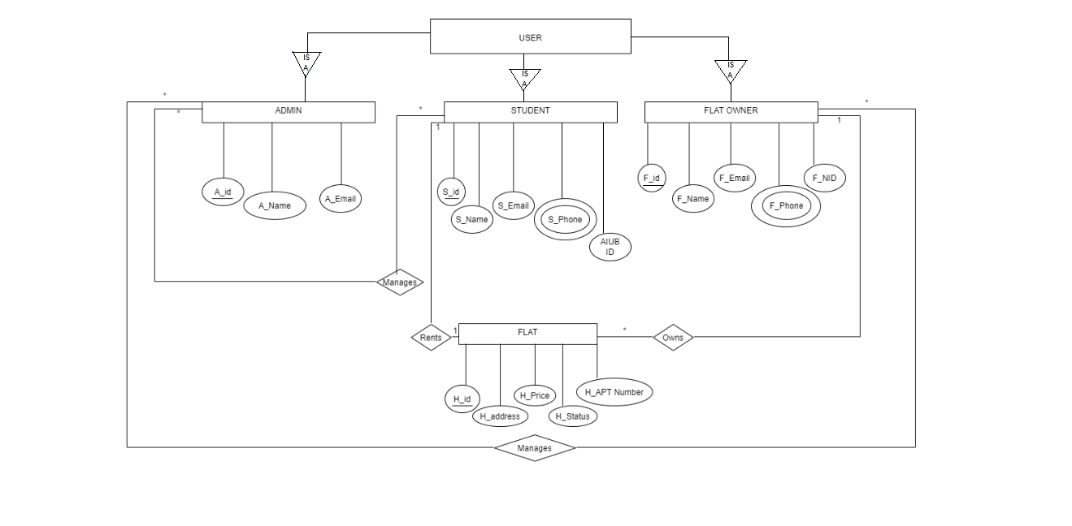

**Forms:**  
1. User registration form  
2. User login form  
3.Update user info  
4. Add house (Flat owner adds a house)  
5. Admin after login form (Delete and search user)  
6.Rent house  
7.Payment  
8.Leave house  
9.Help

**Static Pages:**

1.Admin Homepage

2.Student Homepage

3. House owner Homepage